Depression and Antidepressant Medications

1. Depression
Depression is a significant global health issue, characterized by "persistent low mood, feeling of sadness, and loss of interest." It is recognized as a "medical condition that requires diagnosis and treatment" and is a leading cause of mental disability and premature death worldwide. Depression often co-occurs with other psychiatric conditions such as anxiety, schizophrenia, Parkinson's disease, and drug addiction
Key Symptoms for Diagnosis:
- Depressed Mood: Clients feel "hopeless and empty."
- Anhedonia: "Loss of joy and interest in life."
- Weight Changes: Typically "anorexia" and "rapid weight loss" are more common, though weight gain can also occur.
- Sleep Disturbances: "Insomnia or even hyperomnia (sleeping too much).
- Difficulty Concentrating
- Suicidal Thoughts: "Reoccurrent" suicidal ideation is a critical symptom.
- Loss of energy
- Anger
- Guilt
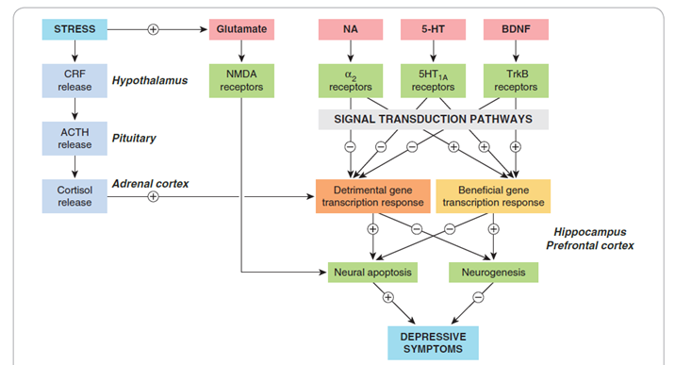

Mechanisms of Depression
The core idea is that stress triggers a cascade of events leading to specific biochemical changes that promote detrimental cellular responses and inhibit beneficial ones in the brain, ultimately resulting in depressive symptoms.
- Stress as a Primary Initiator: Stress is the upstream trigger for the cascade of events.
- HPA Axis Activation: Stress activates the HPA axis (Hypothalamus → Pituitary → Adrenal cortex), leading to CRF → ACTH → Cortisol release.
- Glutamate Excitotoxicity: Stress enhances the "excitotoxic action of glutamate, mediated by NMDA receptors," a prodepressive pathway including HPA Axis.
- Neurotransmitter Roles:
  - Noradrenaline (NA) and 5-hydroxytryptamine (5-HT): These monoamines are involved in "antidepressive pathways" and act on G protein-coupled receptors (α2 and 5HT1A, respectively).
  - Brain-derived neurotrophic factor (BDNF): Also part of "antidepressive pathways," acting on a kinase-linked receptor TrkB receptors.
- Gene Transcription Outcomes:
  - Detrimental pathways "switch on the expression of genes that promote neural apoptosis in the hippocampus and prefrontal cortex," while beneficial pathways "switch on genes that protect neurons against apoptosis and also promote neurogenesis."
- Connection to Symptoms: These cellular outcomes (imbalance between apoptosis and neurogenesis) directly lead to "DEPRESSIVE SYMPTOMS."
Types of Depression:
The several distinct types of depressive syndromes:
- Unipolar Depression: The most common type (approximately 75% of cases), characterized by mood swings always in the same direction (low mood). It is often "clearly associated with stressful life events" and typically lasts 6-9 months. Symptoms include persistent low mood, loss of interest, changes in appetite, sleep disturbances, fatigue, and feelings of worthlessness.
  - Treatment: Primarily SSRIs (e.g., fluoxetine) and cognitive behavioral therapy (CBT).
- Bipolar Affective Disorder: Less common, appearing in early adult life, and characterized by "oscillating depression and mania over a period of a few weeks." It has a "strong hereditary tendency."
  - Treatment: Mood stabilizers (e.g., lithium), anticonvulsants, and sometimes antipsychotics.
- Endogenous Depression: A subtype of major depressive disorder, thought to arise from "internal physiological factors rather than external events," accounting for about 25% of cases, with "no apparent precipitating cause."
  - Treatment: Tricyclic antidepressants (e.g., amitriptyline) or SSRIs.
- Seasonal Affective Disorder (SAD): Also known as winter depression, where individuals experience depressive symptoms annually during winter months. It's more prevalent in northern latitudes (4-6%). Interestingly, many SAD symptoms are "opposite of those found in major depression – increase in appetite, weight gain, more sleep."
  - Treatment: Light therapy, SSRIs, or Vitamin D supplements.
- Postpartum Depression (Baby Blues): A major depressive episode occurring during pregnancy or within four weeks postpartum, involving "intense feelings of sadness, anxiety, and exhaustion that can interfere with a mother's ability to care for herself or her baby."
  - Treatment: SSRIs (e.g., sertraline) are often prescribed due to safety for breastfeeding mothers.
- Dysthymia: A "long-term persistent depression" with "mild symptoms for about 2 years or more."

2. Pathophysiology of Depression
The two central hypotheses regarding the biological basis of depression:

a. Monoamine Theory:
First proposed by Schildkraut in 1965, this hypothesis suggests "the depressive condition is related to a deficiency in the quantity or function of serotonin (5-HT), norepinephrine (NE), and dopamine (DA) in the cortical and limbic regions of the brain." Conversely, "mania results from a functional excess."
- Evidence: Reserpine, which diminishes monoamines, is associated with depression.
- Beyond Monoamines: The excitatory neurotransmitter glutamate is also associated, with "increased glutamate levels in the cerebrospinal fluid of depressed patients."
- Limitations: "Some experimental antidepressants do not work through the monoamine system." For example, ketamine, which is a "potent, high-affinity, noncompetitive NMDA (N-methyl-D-aspartate) receptor antagonist." Ketamine has shown "rapid relief from depression, even for patients resistant to other treatments, with effects lasting up to a week or more."

b. Neurotrophic Hypothesis:
This theory suggests that "nerve growth factors like brain-derived neurotrophic factor (BDNF) are crucial for regulating neural plasticity and neurogenesis."
- Evidence: Depression may be linked to "a reduction in neurotrophic support." Directly infusing BDNF in animal models produces "an antidepressant-like effect." Additionally, "all major classes of antidepressants increase BDNF levels in animal models."
- Brain Regions: Depression and prolonged stress are associated with reduced volume in key brain regions like the hippocampus (involved in memory), anterior cingulate (integrates emotional stimuli and attention), and frontal cortex (memory, learning, emotional processing).
Treatment
Treatment for Major depressive disorder (MDD) involves three phases:
- Acute Phase (6-8 weeks): Characterized by "severe clinical signs" and "suicide risk is very high." The goal is "remission of symptoms and restore the function with anti-depressant medications, psychotherapy."
- Continuation Phase: Focuses on "increased ability to function" and the goal is "to prevent relapse."
- Maintenance Phase (Over 6-12 months): The goal is "to prevent reoccurrence" and for the client to "return to normal functioning."

3. Anti-Depressant Drugs
General Classes of Antidepressants Listed:
- Selective Serotonin Reuptake Inhibitors (SSRIs)
- Serotonin-Norepinephrine Reuptake Inhibitors (SNRIs)
- Tricyclic Antidepressants (TCAs)
- Tetracyclic and Unicyclic Antidepressants
- 5-HT2 Receptor Modulators
- Monoamine Oxidase Inhibitors (MAOIs)
- NMDA Receptor Antagonists
- Melatonin receptor agonists (Agomelatine)
- Herbal Preparations (St. John's wort)

a. Selective Serotonin Reuptake Inhibitors (SSRIs)
- Examples: Fluoxetine, Paroxetine, Sertraline, Citalopram, Escitalopram.
- Mechanism: Inhibit the serotonin transporter (SERT), preventing serotonin reuptake and thus "increasing serotonin signaling" in the synaptic cleft. They act by "allosterically inhibiting the SERT receptor at a site distinct from the serotonin binding site."
- Popularity: Most frequently used due to "ease of administration, safety in overdose situations, affordability," and broad clinical applications.
- Pharmacokinetics: Well absorbed orally, most have 18-24 hour half-lives. Fluoxetine has the longest (24-96 h) due to an active metabolite (nor-fluoxetine).
- Clinical Indications: Approved for acute and long-term treatment of Major Depressive Disorder, various Anxiety Disorders (GAD, PTSD, OCD, Social Anxiety Disorder, Panic Disorder), Premenstrual Dysphoric Disorder (PMDD)(Fluoxetine).
- Adverse Effects: Common side effects include "loss of libido, delayed orgasm, or reduced arousal" (30-40% of patients), headaches, weight gain (paroxetine), and gastrointestinal symptoms (nausea, diarrhea). Sudden discontinuation of short-half-life SSRIs can lead to dizziness and paresthesias.
- Drug Interaction: Serious interaction with MAOIs can cause "Serotonin Syndrome" (hyperthermia, muscle rigidity, rapid changes in mental status and vital signs).
- Overdose: Relatively safe, but can "prolong the cardiac QT interval, giving rise to ventricular arrhythmias."

b. Selective Serotonin-Norepinephrine Reuptake Inhibitors (SNRIs)
- Examples: Venlafaxine, Desvenlafaxine, Duloxetine, Milnacipran, Levomilnacipran.
- Mechanism: Inhibit the reuptake of both serotonin (SERT) and norepinephrine (NET), increasing their levels in the synaptic cleft to achieve antidepressant effects.
- Pharmacodynamics: Venlafaxine is a weak NET inhibitor; others are more balanced. SNRIs generally "have much greater affinity for serotonin SERT than for norepinephrine NET transporter."
- Clinical Indications: Major Depression Disorder, Major Anxiety Disorders, pain disorders (neuropathies, fibromyalgia), stress urinary incontinence, and vasomotor symptoms of menopause.

c. Tricyclic Antidepressants (TCAs)
- Examples: Imipramine, Desipramine, Clomipramine, Amitriptyline, Nortriptyline.
- History: Leading class until SSRIs became available; now less used due to adverse effects.
- Mechanism: Inhibit the reuptake of norepinephrine (NE) and serotonin (5-HT) at presynaptic nerve terminals, increasing their synaptic concentrations.
- Pharmacodynamics: Vary in affinity for SERT vs. NET (e.g., clomipramine for SERT, desipramine for NET).
- Clinical Indications: Depression, neuropathic and pain conditions, enuresis, and insomnia.
- Adverse Effects: Significant anticholinergic effects (dry mouth, constipation, urinary retention, blurred vision, confusion), orthostatic hypotension, weight gain, and sedation.

d. HT2 Receptor Modulators
- Examples: Trazodone, Nefazodone, Vortioxetine.
- Mechanism: Primarily blockade of the 5-HT2A receptor. Vortioxetine acts on multiple serotonin receptors (antagonizes 5-HT3, 5-HT7, 5-HT1D; partially agonizes 5-HT1B; fully agonizes 5-HT1A) and inhibits SERT, but its main effects are not linked to SERT inhibition.
- Clinical Indications: Antianxiety, antipsychotic, antidepressant. Vortioxetine is approved for major depression and cognitive dysfunction linked to depression.
- Adverse Effects: Sedation, gastrointestinal disturbances, orthostatic hypotension. Nefazodone has a "FDA black box warning in 2001 for hepatotoxicity, including fatal hepatic failure." Vortioxetine can cause nausea and sexual dysfunction.
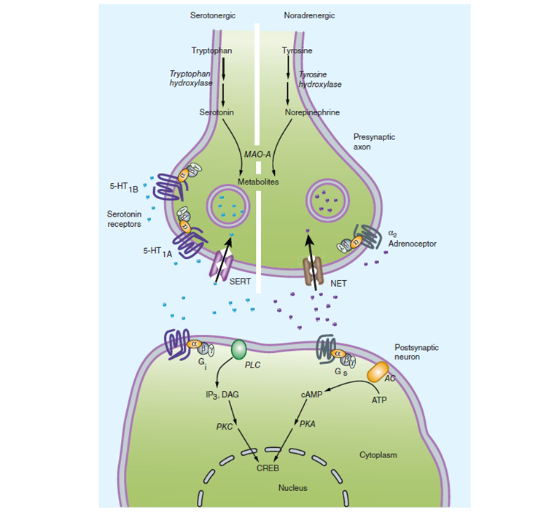

e. Tetracyclic and Unicyclic Antidepressants
- Examples: Bupropion, Mirtazapine, Amoxapine.
  - Bupropion: Has "little to no direct impact on the serotonin system." Its prominent effect is increasing presynaptic release of catecholamines and modest to moderate inhibition of norepinephrine and dopamine reuptake.
    - Bupropion is metabolized into three active metabolites, including hydroxybupropion, which is being developed as an antidepressant. Bupropion has Biphasic elimination: a short 1-hour initial phase followed by a 14-hour second phase.
- Therapeutic Effects: Unique side effect profiles. Mirtazapine is used for weight gain and sedation; bupropion for patients experiencing sexual side effects with other antidepressants.
- Clinical Indications: Bupropion resembles amphetamine (CNS activating properties, benefits in obesity). Mirtazapine for antidepressant effect. Amoxapine has antipsychotic properties.
- Adverse Effects: Bupropion should be avoided with MAOIs. Parkinsonian syndrome (with Amoxapine), sedation, agitation, insomnia, anorexia, GI upset.

f. Monoamine Oxidase Inhibitors (MAOIs)
- Examples: Phenelzine, Isocarboxazid, Selegiline, Moclobemide.
- History: Among the first modern antidepressants (1950s) but "rarely used due to their toxicity." Primarily "reserved for treating depression that is unresponsive to other antidepressants."
- Types of MAO enzymes: MAO-A (metabolizes serotonin, NE, DA) and MAO-B (primarily breaks down DA). Non-selective MAOIs inhibit both; selective MAOIs (e.g., selegiline) target MAO-B.
- Pharmacokinetics: Well absorbed orally, but extensive first-pass effects. Selegiline is available in transdermal and sublingual forms to bypass first-pass effect and reduce food interactions.
- Pharmacodynamics: Moclobemide is a reversible and selective MAO-A inhibitor. Selegiline is an irreversible MAO-B inhibitor (nonselective at higher doses). Phenelzine is irreversible, nonselective MAOIs.
- Clinical Indications: Anxiety disorders (social anxiety, panic disorder), second/third-line for (major depressive disorder) MDD, CNS stimulating effects. Selegiline is used in low doses for Parkinson's disease.
- Adverse Effects & Drug Interaction: Orthostatic hypotension, weight gain, insomnia, restlessness, anorgasmia, sedation, discontinuation syndrome, delirium. Dangerous interaction with tyramine in diet (e.g., "Wine-and-Cheese Reaction") due to increased tyramine levels.

g. Novel-Acting Antidepressants
- Agomelatine: An "agonist at MT1 and MT2 melatonin receptors that improves mood, probably by improving sleep patterns."
- Ketamine: An "NMDA receptor channel blocker," producing "rapid onset antidepressant effects in patients resistant to other therapies."

h. NMDA Receptor Antagonists
- Examples: Ketamine, Esketamine.
- Mechanism: Antagonists of NMDA receptors. Ketamine also "increases dopaminergic activity through dopamine reuptake inhibition" and "enhance the serotonergic pathways."
- Adverse Effects & Drug Interaction: Long-term abuse linked to dependence, auditory/visual hallucinations, and bladder inflammation/ulceration. Combination with MAOIs and sympathomimetics increases blood pressure and heart rate. Combination with CNS depressants (alcohol, benzodiazepines, and barbiturates) increases sedation.

i. GABA Receptor Modulators
- Examples: Brexanolone (allopregnanolone), Zuranolone, Ganaxolone.
- Mechanism: Brexanolone is a "positive allosteric modulator of GABAA receptor both pre and postsynaptically." Allopregnanolone is a neurosteroid with anxiolytic and anticonvulsant properties.
- Clinical Indication: Brexanolone is a "rapidly acting IV antidepressant in women with postpartum depression." Zuranolone for major depression, ganaxolone for PTSD.
- Adverse Effects: Headache, dizziness, somnolence, sedation. Rarely, loss of consciousness and syncope.

j. Medical Procedures for Depression
Beyond medication, several procedures are used, especially for "resistant depression":

Electroconvulsive Therapy (ECT)
  - Mechanism: "Shocks the brain and induces a seizure" to "jumpstart the brain" or "like doing a hard reset on your iPhone." Each seizure lasts "around 15 to 20 seconds."
  - Indications: Proven to treat "clinical depression, schizophrenia and even bipolar." Typically 2-3 times a week for 6-12 treatments.

